Epsom & Ewell F.C.
27
v
Colliers Wood United
Friday, 14th April 2017 – 1.00 p.m.
Good afternoon! We welcome the players, supporters and officials of Colliers Wood United Football Club, today’s officials and our own regular faces for today’s League match.

We also wish you Happy Easter! This is our traditional (well it’s the second time we’ve done it!) Good Friday fixture and whilst the crowd today is unlikely to be as large as it was last year, there was always a second reason for bringing the game forward a day which is the extra day recovery time before the Easter Monday fixtures are played. Let’s hope it works out for both of us!

Our opponents today are the second longest continual serving team in the Premier Division having remained in the top flight since 2004 after Raynes Park Vale. However, both Vale and Bedfont & Feltham are now confirmed as relegated, so the mantle will shortly pass to the Wood. Just out of interest, after Colliers Wood, did you know that the next two longest serving clubs are ourselves and Camberley Town! Doesn’t seem that long ago that we were transferred over (2006/07)!

We were last at High Road when we met Farnham Town nearly three weeks ago and fought back to equalise twice in a 2-2 draw, before being defeated 2-0 at Camberley Town in a match to forget. Happily we bounced back last Saturday with a 2-1 win at Knaphill, capped by Adam Heagney’s first goal for the club from over thirty yards to secure the points!

Quickly looking forward to the League Cup Final against Westfield on Friday 5th May, we are running a coach to Windsor with a price of £10 which leaves from The Kingsway in Ewell Village at 4.30pm, although there will be another stop at Tolworth Railway Station if that is easier. If you are interested, please let a Committee Member know urgently as spaces are filling up!

You will also note that the Player of the Year form is out today. You can return them to us either this afternoon or at next Saturday’s match against North Greenford United and remember that if you are a current club Member your vote counts for double points. Steve Dyke has a list so why not check whether you are paid up, and if not, why not join up, it’s only £6!

Our Presentation Evening is now set for the Green Man Public House in Ewell at 8pm next Saturday with a £5 entry charge which will include food. It starts slightly later than usual as we are aware that Chelsea and Tottenham meet in an F.A. Cup Semi-Final at 5.15 and we know our place! Again, please see a Committee Member to pick up your ticket.

We make the short visit to Horley Town on Monday and complete our League season back here on Saturday against North Greenford United. See you then!

Enjoy the game!

Rich

You can follow us on Facebook: www.facebook.com/epsomandewellfc
Twitter: @EEFCOfficial Instagram at: www.instagram.com/epsomandewellfc
and Youtube at: www.youtube.com/channel/UCtLrpS0x5OaYUACRT34_zng

Today’s Cover Photos by Gemma Jarman

- Our line up before the Farnham match on 25th March in their new G4 Contracts kit

- Kyle Hough scores against Colliers Wood here on 4th April 2015

Cherry Red Records Combined Counties League
Premier Division Table 2016/17
inc Tuesday 11th April | P | W | D | L | F | A | Pts | GD | H | A
Hartley Wintney | 41 | 33 | 5 | 3 | 125 | 37 | 104 | +88 | 0-1 | 1-3
Westfield | 40 | 24 | 9 | 7 | 91 | 49 | 81 | +42 | 2-1 | 1-2
Walton & Hersham | 41 | 21 | 14 | 6 | 68 | 38 | 77 | +30 | 1-1 | 1-1
Hanworth Villa | 41 | 22 | 9 | 10 | 69 | 43 | 75 | +26 | 2-2 | 0-1
Epsom & Ewell | 41 | 21 | 10 | 10 | 85 | 53 | 73 | +32 | X | X
Camberley Town | 41 | 21 | 6 | 14 | 80 | 54 | 69 | +26 | 0-0 | 0-2
Horley Town | 41 | 19 | 7 | 15 | 81 | 64 | 64 | +17 | 3-0 | 17/4
Abbey Rangers | 42 | 17 | 11 | 14 | 68 | 69 | 62 | -1 | 7-1 | 1-0
Spelthorne Sports | 40 | 16 | 9 | 15 | 72 | 69 | 57 | +3 | 3-2 | 2-2
Knaphill | 41 | 17 | 5 | 19 | 75 | 76 | 56 | -1 | 4-0 | 2-1
Sutton Common Rovers | 40 | 17 | 5 | 18 | 59 | 61 | 56 | -2 | 2-1 | 1-1
Bedfont Sports | 39 | 15 | 10 | 14 | 67 | 72 | 55 | -5 | 5-1 | 3-1
Windsor | 41 | 15 | 9 | 17 | 73 | 68 | 54 | +5 | 2-0 | 1-2
North Greenford United | 39 | 15 | 9 | 15 | 71 | 69 | 54 | +2 | 22/4 | 1-2
Guildford City | 41 | 14 | 7 | 20 | 73 | 81 | 49 | -8 | 1-0 | 2-0
AFC Hayes | 40 | 13 | 9 | 18 | 62 | 73 | 48 | -11 | 2-2 | 0-1
Colliers Wood United | 41 | 12 | 11 | 18 | 65 | 75 | 47 | -10 | - | 0-5
Farnham Town | 41 | 13 | 7 | 21 | 58 | 78 | 46 | -20 | 2-2 | 2-1
Chertsey Town | 41 | 13 | 7 | 21 | 54 | 88 | 46 | -34 | 2-1 | 3-0
CB Hounslow United | 41 | 13 | 5 | 23 | 53 | 79 | 44 | -26 | 1-5 | 2-0
Badshot Lea | 41 | 10 | 5 | 26 | 59 | 108 | 35 | -49 | 4-2 | 4-1
Raynes Park Vale | 41 | 7 | 9 | 25 | 42 | 83 | 30 | -41 | 1-1 | 1-1
Bedfont & Feltham | 41 | 8 | 6 | 27 | 53 | 116 | 30 | -63 | 4-1 | 9-2

Lucky Day? – 14th April
Played 16 - Won 10 Drawn 1 Lost 5 - For 34 Against 18 - PPG 1.94 - Very Good
Our Club record against today’s opponent
Played 22 - Won 14 Drawn 2 Lost 6 - For 45 Against 33 - PPG 2.00 - Very Good
Our Largest wins and losses against today’s opponent
8th March 2014 - W 4-0 - Combined Counties League (H)
26th August 2016 - L 0-5 - Combined Counties League (A)
Their Last Visit
8th September 2015 - Won 3-1 - Combined Counties League

First Eleven Appearances 2016/17 - (max 52)
Name | Debut | 2016/17 |  |  |  | Career Totals
 |  | App | Sub | Total | Goals | App | Sub | Total | Goals
CLARK-GLEAVE Charlie* | 23/08/2016 | 3 | 2 | 5 | 0 | 3 | 2 | 5 | 0
COOPER-SMITH Daryl | 03/01/2015 | 34 | 5 | 39 | 31 | 64 | 13 | 77 | 51
DEAN Dan | 02/08/2014 | 38 | 2 | 40 | 2 | 106 | 6 | 112 | 4
DEWAR Ali | 29/10/2011 | 0 | 5 | 5 | 0 | 55 | 40 | 95 | 10
EACOTT Michael | 02/08/2014 | 43 | 0 | 43 | 0 | 128 | 1 | 129 | 0
FARRELL Matt | 02/08/2014 | 48 | 0 | 48 | 17 | 134 | 4 | 138 | 35
FERDINANDO Matt | 20/09/2014 | 29 | 9 | 38 | 10 | 82 | 15 | 97 | 24
GALLAGHER Jordan | 07/08/2016 | 37 | 13 | 50 | 12 | 37 | 13 | 50 | 12
GRIFFIN Reisse | 08/08/2015 | 41 | 7 | 48 | 3 | 69 | 13 | 82 | 5
HASTINGS Craig | 08/08/2015 | 32 | 7 | 39 | 2 | 69 | 11 | 80 | 2
HEAGNEY Adam | 16/08/2016 | 35 | 7 | 42 | 1 | 35 | 7 | 42 | 1
HENDRY Rob | 08/08/2015 | 36 | 10 | 46 | 10 | 66 | 21 | 87 | 22
MCKAY Alex | 20/12/2008 | 20 | 7 | 27 | 4 | 128 | 37 | 165 | 12
NEALE Tom* | 13/10/2015 | 6 | 5 | 11 | 7 | 22 | 24 | 46 | 17
NORTH Rhys | 16/08/2015 | 5 | 3 | 8 | 0 | 22 | 10 | 32 | 1
NWACHUKWU Jason | 01/10/2016 | 15 | 14 | 29 | 1 | 15 | 14 | 29 | 1
PANAYIOTOU Savvas | 03/01/2015 | 43 | 5 | 48 | 5 | 75 | 13 | 88 | 12
PRICE Matt* | 23/08/2016 | 2 | 0 | 2 | 1 | 2 | 0 | 2 | 1
ROBINSON Sam* | 22/10/2011 | 7 | 1 | 8 | 1 | 61 | 6 | 67 | 14
ROSE Daniel | 25/10/2016 | 2 | 5 | 7 | 0 | 2 | 5 | 7 | 0
SALEH Mennar* | 24/09/2016 | 0 | 2 | 2 | 0 | 0 | 2 | 2 | 0
SMITH Matt | 08/08/2009 | 0 | 3 | 3 | 1 | 91 | 46 | 137 | 11
TANTON Matt | 02/08/2014 | 41 | 2 | 43 | 1 | 98 | 6 | 104 | 3
TAYLOR James | 26/08/2013 | 42 | 3 | 45 | 2 | 128 | 15 | 143 | 8
THOMPSON Elliott | 09/02/2016 | 3 | 0 | 3 | 1 | 7 | 9 | 16 | 1
TURPIE Alistair | 31/03/2016 | 9 | 1 | 10 | 0 | 11 | 1 | 12 | 0
WATRET Jack* | 02/08/2016 | 1 | 0 | 1 | 0 | 1 | 0 | 1 | 0
Own goals |  |  |  |  | 1
* player has left the club

Latest Results and Fixtures
Combined Counties League – Saturday 25th March
Badshot Lea | 1-3 | Sutton Common Rovers
CB Hounslow United | 0-2 | Abbey Rangers
Chertsey Town | 2-0 | Colliers Wood United
Epsom & Ewell | 2-2 | Farnham Town
Guildford City | 1-0 | Walton & Hersham
Hartley Wintney | 0-1 | Horley Town
Knaphill | 0-1 | North Greenford United
Raynes Park Vale | 0-2 | Camberley Town
Westfield | 3-2 | Bedfont & Feltham
Windsor | 1-2 | AFC Hayes
Combined Counties League – Monday 27th March
Sutton Common Rovers | 3-1 | Windsor
Combined Counties League – Tuesday 28th March
Knaphill | 4-0 | Bedfont & Feltham
North Greenford United | 1-1 | Colliers Wood United
Raynes Park Vale | 1-0 | CB Hounslow United
Walton & Hersham | 0-0 | Hanworth Villa
Combined Counties League – Wednesday 29th March
Bedfont Sports | 0-2 | Camberley Town
Combined Counties League – Saturday 1st April
Abbey Rangers | 1-0 | Westfield
AFC Hayes | 2-0 | Raynes Park Vale
Bedfont & Feltham | 1-2 | Spelthorne Sports
Camberley Town | 2-0 | Epsom & Ewell
Chertsey Town | 0-0 | Hartley Wintney
Colliers Wood United | 1-0 | Knaphill
Farnham Town | 0-1 | CB Hounslow United
Hanworth Villa | 1-2 | Windsor
Horley Town | 1-1 | Badshot Lea
North Greenford United | 1-1 | Bedfont Sports
Sutton Common Rovers | 2-2 | Guildford City
Combined Counties League – Tuesday 4th April
Bedfont Sports | 2-2 | CB Hounslow United
Chertsey Town | 0-1 | Sutton Common Rovers
Hartley Wintney | 2-1 | Windsor
North Greenford United | 0-3 | Camberley Town
Combined Counties League – Saturday 8th April
Abbey Rangers | 1-4 | Colliers Wood United
Badshot Lea | 1-3 | Windsor
CB Hounslow United | 0-3 | Bedfont & Feltham
Farnham Town | 0-1 | Horley Town
Guildford City | 0-1 | Hartley Wintney
Hanworth Villa | 0-2 | Bedfont Sports
Knaphill | 1-2 | Epsom & Ewell
Latest Results and Fixtures
Combined Counties League – Saturday 8th April
Raynes Park Vale | 1-1 | North Greenford United
Spelthorne Sports | 2-1 | Chertsey Town
Walton & Hersham | 2-0 | Camberley Town
Westfield | 4-1 | Sutton Common Rovers
Combined Counties League – Tuesday 11th April
Bedfont Sports | 3-3 | Westfield
Knaphill | 3-3 | Colliers Wood United
Combined Counties League – Friday 14th April
Epsom & Ewell | V | Colliers Wood United
Combined Counties League – Saturday 15th April
AFC Hayes | V | Knaphill
Bedfont Sports | V | Abbey Rangers
CB Hounslow United | V | Walton & Hersham
Chertsey Town | V | Camberley Town
Hanworth Villa | V | Horley Town
Hartley Wintney | V | Sutton Common Rovers
Raynes Park Vale | V | Bedfont & Feltham
Spelthorne Sports | V | Farnham Town
Westfield | V | Badshot Lea
Windsor | V | North Greenford United
Combined Counties League – Monday 17th April (11.30am k.o. unless advised below)
Abbey Rangers | 1.00pm | Chertsey Town
Badshot Lea | V | Guildford City
Bedfont & Feltham | V | Bedfont Sports
Camberley Town | V | Hartley Wintney
Farnham Town | V | Westfield
Horley Town | V | Epsom & Ewell
Knaphill | V | Spelthorne Sports
North Greenford United | 1.00pm | AFC Hayes
Sutton Common Rovers | V | Raynes Park Vale
Walton & Hersham | V | Windsor
Combined Counties League – Tuesday 18th April
CB Hounslow United | V | Hanworth Villa
Combined Counties League – Saturday 22nd April
AFC Hayes | V | Badshot Lea
Bedfont Sports | V | Knaphill
Chertsey Town | V | Farnham Town
Epsom & Ewell | V | North Greenford United
Guildford City | V | Bedfont & Feltham
Hanworth Villa | V | Sutton Common Rovers
Hartley Wintney | V | Walton & Hersham
Raynes Park Vale | V | Horley Town
Spelthorne Sports | V | Colliers Wood United
Westfield | V | CB Hounslow United
Windsor | V | Camberley Town

From behind the goal
Epsom & Ewell 2-2 Farnham Town
Combined Counties League - Premier Division - Saturday 25th March 2017

Salts have to dig deep to retrieve a point

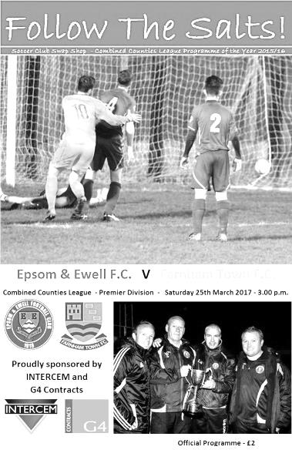
On an extremely blustery day at Chipstead exactly 50 spectators witnessed a fairly uneventful draw. This might sound strange, seeing as there were four goals but much of the match was spoilt by the windy conditions and if I'm honest, a lot of the decision making out there.

After two very difficult and challenging matches against Hartley Wintney and Windsor there were always likely to be a few changes for our third home match in seven days. At the back, Reisse Griffin came in for James Taylor, while up front Jason Nwachukwu came on for Jordan Gallagher. In midfield Agi Panayiotou was given a rest and Alex McKay took his place in the holding role, and it was McKay who would have a big part to play as the story of the match unfolded.

The first five minutes of the match took place in a small segment of the field on the stand side where it appeared that neither team were able to advance the ball more than a few feet before conceding a throw in. However, in the 8th minute we spread the ball across the field where McKay then decided to send the ball back to Michael Eacott. However, the back pass held up in the wind and was a present for Jon Lancashire who rounded the exposed Michael Eacott to tuck the ball into the empty net.

This wasn't to be the first time we would take risks with a back pass and on a windy day on a firm and bobbly pitch, the tactic was a massive risk. Inevitably when the ball was cleared upfield by Eacott we were fifty-fifty at best for retaining the ball and the windy conditions made it even more difficult to find a player. It was a lottery that wasn't worth playing. Fortunately, we were back on level terms in the 15th minute after a surging run to the touchline from Matt Tanton who cut the ball back to the near post where McKay was able to smash the ball into the roof of the net from 6 yards to redeem for his earlier error. The opposition were claiming that the ball had run out of play before our full back sent the ball across, but I had a pretty close view of this and I'm happy that it didn't even touch the line before being delivered.

With the majority of the wind at our backs we started to get on top a little. A foul on Matt Ferdinando earned the visiting Captain Darren Wilson a yellow card but their excellent keeper Richard Ossai, one of an elite group to have saved a Kyle Hough penalty a few years back, made a fine save as the free kick was sent powerfully towards the far side of the goal to concede a corner, although this was wasted.

Just after the half hour Daryl Cooper-Smith did really well to keep the ball in as Dan Dean sent the ball towards the corner flag. From there he showed great skill to nutmeg a defender in close attendance and then beat another man in the penalty area before having his shot blocked and the danger cleared. You could argue that a pass might have been a better option with Ferdinando in

close attendance, but it would have been one of the goals of the season had he scored so I don't blame him for having a go!

Unfortunately the tempo dropped and all we had to show for the remainder of the half was a couple of fairly weak shots when maybe there were better choices out there, one of these came from Ferdinando who then picked up an injury just before the half and was replaced by Gallagher. Right at the end of the half the visitors reminded us that they were still very much in the match as a deep right wing cross was headed just over the bar at the far post.

The second half had no sooner started before we were behind again. In the 48th minute McKay called for the ball from a long goal kick but was deceived by the wind and the ball dropped over him. With other players nearby not expecting this to happen, the ball bounced through them and Lancashire was able to score his second of the day as he ran on to it and steered the ball under the advancing Eacott. Another couple of chances followed for the visitors as we really didn't get going, one of which came from a free kick and was headed narrowly over the bar.

We were beginning to find a bit of freedom out on the left though. Gallagher was giving visiting full back George Horner a bit too much to handle and the defender wasn't getting a lot of help from his team mates at first. One cross from the left found Rob Hendry just on the edge of the area but he hooked his shot just wide of the post, while on another occasion Cooper-Smith sent a shot in on goal from 25 yards but it was just beyond the far post. Eventually we equalised and it was no real surprise that the goal came from a Gallagher left wing cross. Maybe the surprise was that Griffin was the scorer, having sneaked forward from his full back position unnoticed and he managed to guide the ball off his left thigh into the top corner of the net from a few yards out in the 68th minute.

There were further half chances to both teams as the match neared its end, A Gallagher free kick caused a bit of panic in the Farnham box and Cooper-Smith just got his toe to the ball ahead of Ossai but was at full stretch and couldn't keep it in play. However, at the other end we only half cleared a free kick and had to watch with concern as a volley back in flew just wide of Eacott's left hand post. Eacott then had to be alert to tip a bouncing ball just over the bar which would have caused maximum embarrassment had it gone in as the delivery was from some sixty yards away by Ossai himself!

Whether or not Cooper-Smith had injured himself in stretching for the ball previously was not clear, but he was taken off with eight minutes remaining as we unleashed Panayiotou onto the opposition and he was extremely busy for the remainder of the game with his constant running. I fully understand why he was given a rest but I'm sure that if he had played the whole 90 minutes we'd have won this match. Ultimately though we didn't deserve the win and the final action came when Gallagher had another attack on the left but faced finally with a second defender to deal with, he couldn't decide which way to go and never got the cross over at all.

It was quite an appropriate way for the match to end really as decision making hurt us today. Farnham are a decent team that worked hard, but if we want a top four finish we cannot afford another performance like this, our worst for a few months, even allowing for the wind that had blown constantly throughout the match and continued into the evening.

Check out a different style of report for this match on page 27

Epsom and Ewell: Michael Eacott, Reisse Griffin, Matt Tanton, Craig Hastings,
Dan Dean (c), Alex McKay, Rob Hendry, Matt Farrell, Daryl Cooper-Smith,
Matt Ferdinando, Jason Nwachukwu

Sub: Jordan Gallagher for Ferdinando (44),
Savvas 'Agi' Panayiotou for Cooper-Smith (82)

#
From behind the goal
Camberley Town 2-0 Epsom & Ewell
Combined Counties League - Premier Division - Saturday 1st April 2017

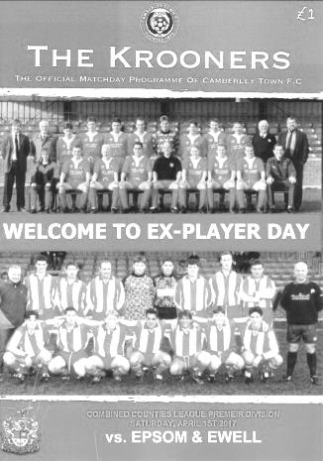
Salts well below par in game to forget

Two first half goals, one well taken, the other fortuitous were enough to consign the Salts to defeat at Krooner Park, but that's almost all you can say about the football side of this match as the two teams combined to create a horrible footballing contest, ineptly officiated and totally devoid of any quality for the 172 spectators who had gathered there, partly for a Camberley Past Players day and partly in the hope that these two top six teams would produce a cracker worthy of some previous battles between the two clubs. Most of the locals who attended would have been happy with the end result, but for our boys it was a match to forget.

It was a day when most things went wrong for us, starting with the late arrival of some players due to M25 traffic tailbacks and ending with a depressing result that probably means we need to win all four of our remaining League matches to have even a remote chance of finishing in the top four at the end of the season.

We shuffled the pack a little this week with Ali Turpie coming in for the rested Michael Eacott and with Adam Heagney coming back into the starting eleven at the expense of Matt Tanton who is one booking away from a suspension. Alongside him James Taylor was in for Craig Hastings, while in midfield Agi Panayiotou came in for Alex McKay and with Rhys North replacing injured Matt Ferdinando on the right and Jordan Gallagher taking Rob Hendry's place on the left. The versatile Reisse Griffin, who had started the season on the right wing, found himself at left back just seven days after appearing at right back!

This was a match where we started slowly and never really got going. Turpie had to be alert to tip a mishit deep cross shot over the bar as the home team started fairly well, peppering our box with a number of enormous long throws from Chris Ellis, many of which were even reaching our far post.

A worrying situation occurred early on when Jordan Gallagher was flagged offside on the left wing despite being nowhere near Jason Nwachukwu who was competing for the ball in the middle of the park with a defender. In fact, whenever the game appeared likely to produce a moment of excitement, it was immediately strangled by one or other of the officiating team, who on an "out of their depth" scale, were somewhere between the River Thames and the English Channel! Three times in the opening fifteen minutes Heagney was fouled, one of which ended with him almost pushed into the fencing. Of course, our first foul then picked up the first yellow card of the match when Griffin was a fraction late on his man. The frustration from this was evident as you could see our Captain Dan Dean trying to get some clarification from the official as to exactly why this deserved a card when the earlier fouls on Heagney had not. This decision had a direct bearing on the opening goal in the 25th minute as a free kick was sent in to the near post. Griffin maybe stood off his man a little more than he would have done had he not recently been booked and Dan Jewell controlled the ball brilliantly, turning to fire home from around 12 yards. Moments later Jamie Hoppitt finally went into the book for yet another foul on Heagney, just after we had quite clearly headed a ball out for a corner to Camberley, only to see a goal kick awarded!

The goal was just about the only bit of skill on show in the entire match and looking back, quite out of character for a game such as this. We remained lethargic in our actions and another shot whizzed across the face of our goal and away to safety before we invited more trouble when Turpie miscontrolled a ball on the bobbly surface and conceded a corner. Luckily that didn't cost us.

There was another test of the referee's capability shortly afterwards as both teams sensed weakness and started to question his authority. There was a foul on North by Liam Roberts, or at least, there appeared

to be but no free kick was awarded. However, about a minute later, by which time the ball had gone out of play for a goal kick, the referee went back to Roberts and booked him. Most were puzzled by the fact that the card had not been given but not the foul, and then within a minute North got ahead of Roberts who then brought him down clumsily. This time the referee awarded the free kick and I am certain that had Roberts not been previously booked, he would have seen a yellow here, but despite a period of uncertainty where the referee consulted with his Assistant, no further card was forthcoming.

Taylor was booked for a foul on the edge of the box before things got worse in the 42nd minute. A free kick was over the top of our defence and Dean reached it, but at full stretch he could only head the ball back towards goal. Unfortunately, Turpie had maybe thought that he wasn't going to reach it and had come off his line a little, being wrong footed by the header and was only able to palm it into the net for a soft second goal. Dean nearly reduced the arrears at the other end within a minute as a deep corner was met with a powerful header, but the ball was blocked on the line by Roberts and it flew away to safety.

Despite the first half being very low on quality, the second half of this match was even worse to watch. With the home side happy to wind the clock down, every throw in became a set piece that England Rugby Union star kicker Owen Farrell would have been hard pressed to take any longer with. This was highlighted in the 62nd minute when Ellis' long throw was headed across the field for another throw on the other side, so he promptly jogged slowly all the way across the field to prepare himself to launch another long bomb towards our goal. From this we had another contentious issue as Marcus Cousins threw himself to the ground in the penalty area quite theatrically, yet despite there being a sum total of eleven cards issued in the match, nothing was given out here. It was at times like watching the American WWE Wrestling with the official who gets distracted by one incident, only to then miss the chair being smashed over the head of the other man! We then had a break up the field and with players over this looked promising but because Hoppitt then fell to the ground clutching his head, the referee suddenly stopped play. A cynic would say that it was almost as if he didn't want play to continue because he wasn't fit enough to keep up....

In between the aerial assault of death by throw in, the hosts got a low shot in with fifteen minutes remaining but Turpie made a good save. Of course actual football would not last for long before another incident occurred when Gallagher appeared to be fouled and fell on the ball, not very smartly retrieving it with his hand. Of course, this was going to earn him a yellow card, but not before substitute Elliott Amadieu had got a quick back heel in on the prostrate Gallagher. What exactly the referee saw at this point is hard to determine but the Camberley man received a yellow card. Either he saw the violent conduct or he didn't, so it should have either been a red card or nothing. Further consultations with his Assistant were of little use, although he then booked Cousins for running to get involved and then Heagney who had been around the incident, but I didn't actually see him do anything to earn a card! The final massive inconsistency occurred in the 87th minute when Cooper-Smith got through on goal but his shot on target, our only one of the match, was well blocked by Stuart Norman in the Camberley goal. The nearby defender then complained to the Assistant for missing an offside who admitted that he got it wrong but then told the defender to "shut his mouth and get on with it". Funny isn't it how this "Respect" initiative appears to be a one way street; made up by former officials to protect current ones!

As we approached injury time substitute Hendry almost got on the scoresheet when he got on the end of a sliced clearance but his shot was guided just wide of Norman's right hand post and the final action came in the eighth minute of added time when Gallagher hit the bar from a free kick out wide. Although we can complain about some of the decisions out there which were consistent only in their inaccuracy, we weren't good enough today and need to find a better way of dealing with Camberley's even more direct than usual style which it has to be said was not attractive to watch at all. Their player of the match on the day was Ellis, who probably had the ball in his hands for longer than he had it at his feet. I like coming to Krooner Park; they have nice people there and we have always got on well. However, I wouldn't want to watch their team for more than 180 minutes in a season. See you next season guys!

Epsom and Ewell: Ali Turpie, Adam Heagney, Reisse Griffin, James Taylor, Dan Dean (c), Savvas 'Agi' Panayiotou, Jordan Gallagher, Matt Farrell, Daryl Cooper-Smith, Jason Nwachukwu, Rhys North
Sub: Rob Hendry for North (65), Alex McKay for Farrell (77)

Club Records - 14th April
Date | Day | Competition |  | Opponents |  | Scorers
14/04/28 | Sat | London League | A | Mitcham Wanderers | 2-0 | R.Wilcox, R.Marlow
14/04/33 | Fri | London League | A | Tooting & Mitcham United | 4-0 | L.Marlow (2), J.Jones, J.Gillespie
14/04/34 | Sat | Friendly | H | Met Police | 3-0 | J.Jones, L.Marlow, L.Graves
14/04/52 | Mon | Corinthian Memorial Shield F | N | Hounslow Town | 1-2 | D.Ford
14/04/56 | Sat | Corinthian League | H | Chesham United | 3-2 | J.Berry, T.Day, R.Colfar
14/04/62 | Sat | Corinthian League | A | Slough Town | 0-2
14/04/81 | Tue | Surrey Senior Cup SF replay | H | Sutton United | 3-2 | D.Hanks (2), T.Tuite
14/04/84 | Sat | Isthmian League 1 | H | Kingstonian | 3-2 | J.Russell (2 pens), S.Milton
14/04/87 | Tue | Isthmian League 1 | A | Hampton | 0-1
14/04/90 | Sat | Isthmian League 2s | A | Malden Vale | 5-0 | J.Dack, L.Edwards, C.Hadingham (2), C.Walcott
14/04/94 | Thur | Isthmian League 3 | H | East Thurrock United | 2-2 | R.Purvis, N.Webb
14/04/98 | Tue | Isthmian League 3 | H | Wingate & Finchley | 2-0 | S.Smith, A.Rawlinson
14/04/01 | Sat | Isthmian League 3 | A | Chalfont St Peter | 2-1 | B.Forey, D.Marvell
14/04/07 | Sat | Combined Counties  Premier Division | H | Camberley Town | 1-2 | D.Marvell (pen)
14/04/10 | Wed | Combined Counties  Premier Division | A | Guildford City | 1-2 | R.Burns
14/04/12 | Sat | Combined Counties  Premier Division | A | Egham Town | 2-0 | o.g., R.Bedj Bedj (pen)
Historical Decades
Date | Day | Competition |  | Opponents |  | Scorers
90 years ago – Epsom Town F.C.
15/04/27 | Fri | Surrey Senior League | A | Egham | 2-0 | J.Parr, F.Watts
80 years ago – Epsom F.C.
17/04/37 | Sat | London League | H | Finchley | 1-1 | A.Griffiths
70 years ago – Epsom F.C.
19/04/47 | Sat | London League | A | Bedford Town Reserves | 1-4 | K.Minter
60 years ago – Epsom F.C.
13/04/57 | Sat | Corinthian League | H | Worthing | 1-0 | R.Colfar
50 years ago – Epsom & Ewell F.C.
15/04/67 | Sat | Athenian League 2 | A | Boreham Wood | 0-4
40 years ago – Epsom & Ewell F.C.
16/04/77 | Sat | Athenian League 1 | H | Letchworth Garden City | 0-1
30 years ago – Epsom & Ewell F.C.
14/04/87 | Tue | Isthmian League 1 | A | Hampton | 0-1
20 years ago – Epsom & Ewell F.C.
15/04/97 | Tue | Isthmian League 3 | H | Wingate & Finchley | 4-7 | T.Smith (2), A.Rawlinson, A.Boxall
10 years ago – Epsom & Ewell F.C.
14/04/07 | Sat | Combined Counties  Premier Division | H | Camberley Town | 1-2 | D.Marvell (pen)

History Corner – 14th April
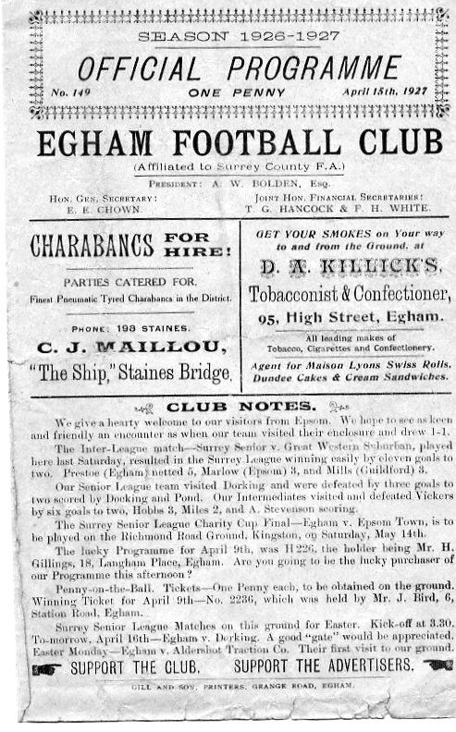
90 years ago this week we travelled to Egham F.C. for a Surrey Senior League match. (see programme left) They were no connection to the current club as this team folded before the War and the new club were founded in 1963 but they were as well supported in those days as any of the other big local sides and 2,000 were present for this Good Friday fixture which we won 2-0 thanks to goals from Jack Parr and Fred Watts. We would return a few weeks later to defeat the host club 1-0 and secure the first League and League Cup double of our short history.

55 years ago today we travelled down to The Saffrons, home of Eastbourne F.C. (later Eastbourne Town) for a Corinthian League Memorial Shield Final against Hounslow. (see programme right – number 682!) 5,000 were present which begs the question about how large the attendance might have been if the match had been held in London, and we led for an hour against the League Champions through a Denis Ford goal, but conceded twice towards the end to a powerful team that would go on to become one of the best Amateur teams throughout the fifties and early sixties.

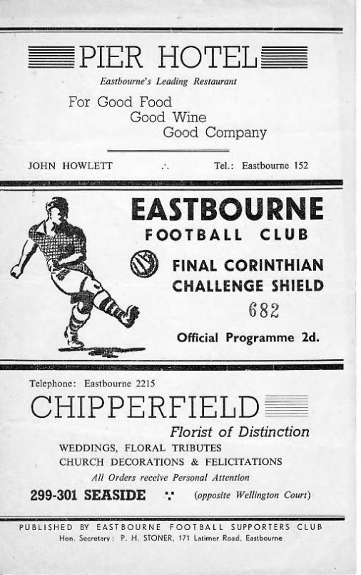
Beaten but not disgraced, we were finally comfortable in our new surroundings of the Corinthian League after going nearly three seasons without an away win until the January of 1952 and would finish third the following year under new Player / Coach Pat Lynch.

36 years ago this week we hosted rivals Sutton United at West Street in the Surrey Senior Cup Semi-Final replay, following a goalless draw at Gander Green Lane. They were going to Wembley in the F.A. Trophy Final that season but we were a good team ourselves and a see-saw match ended up 3-2 in our favour with our lads going on to lift the Cup a few days later against Woking at Sandy Lane, the old home of Tooting & Mitcham United. In four matches that season, neither Sutton United, nor the Trophy winners Bishops Stortford would defeat us.

EL Records Premier Challenge Cup
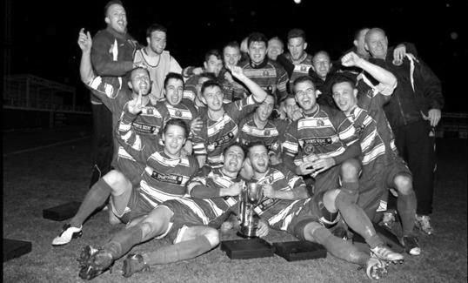
Second Round
Hanworth Villa | 2-4+ | Epsom and Ewell
AFC Hayes | 3-4 | Balham
Epsom Athletic | 1-5 | Windsor
Sutton Common Rovers | 2-1 | Bedfont Sports
Raynes Park Vale | 2-0 | Colliers Wood United
Frimley Green | 1-2 | Banstead Athletic
Westfield | 8-4+ | Redhill
Staines Lammas | 0-1 | Farnham Town
Worcester Park | 8-1 | Cove
Badshot Lea | 0-5 | Guildford City
Chertsey Town | 1-2 | Camberley Town
Cobham | 1-3 | Chessington & Hook United
Hartley Wintney | 4-0 | AC London
Horley Town | 2-2+ 5-4p | Sheerwater
Walton & Hersham | 5-1 | Eversley & California
Ash United | 2-0 | Farleigh Rovers
Third Round
Banstead Athletic | 4-4+ 3-4p | Westfield
Sutton Common Rovers | 1-3 | Walton & Hersham
Farnham Town | 0-4 | Camberley Town
Ash United | 0-2 | Windsor
Raynes Park Vale | 2-1 | Hartley Wintney
Guildford City | 2-1 | Balham
Horley Town | 2-0 | Chessington & Hook United
Worcester Park | 3-6 | Epsom & Ewell
Quarter Finals
Windsor | 2-0 | Horley Town
Guildford City | 1-2 | Raynes Park Vale
Westfield | 4-1 | Camberley Town
Walton & Hersham | 1-3 | Epsom & Ewell
Semi Finals
Epsom & Ewell | 2-0 | Windsor
Raynes Park Vale | 0-4 | Westfield
Final @ Windsor F.C. – Friday 5th May – 7.45pm k.o.
Epsom & Ewell | V | Westfield

Salts Super Six Predictor
The Salts Super Six Predictor is live again for today’s match and the tickets are on sale at today’s game to the left of the gate. The matches are to be played on Saturday 15th April.

The jackpot has already climbed to £316 which is fairly large and who knows how much higher it could rise!

The competition is easy to play! To win, you simply need to predict the results of six matches correctly from the three options, fill in the form and make sure it is back with our seller before the deadline on the ticket. The latest fixtures are shown below.

If you are a club regular, you just need to place your name on the sheet, although if you aren’t, then we’ll need a contact number from you too. We will announce any winners on the website within three working days, so don’t worry, we won’t miss you!

Please note that if there is more than one winner, the prize pot would be shared between the winners. All you need to do now is have a go, as many times as you like!
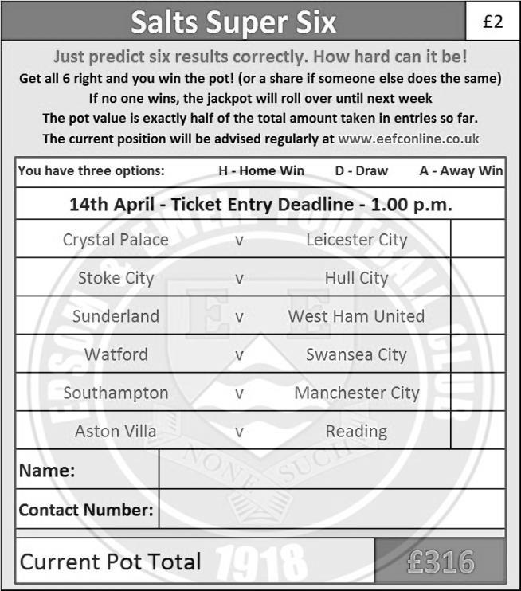

Good luck!

Centre page for results

Centre page for results

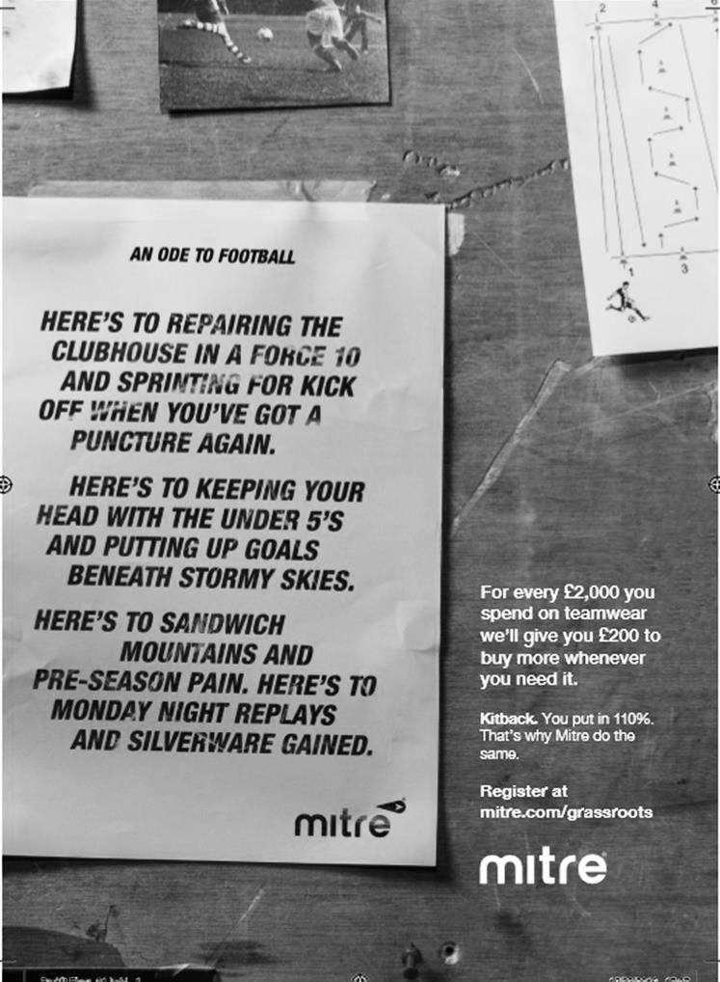

Colliers Wood United – History
The club, one of the oldest in the country, and which has now been in existence for 141 years, received a well-deserved recognition award from the FA for 125 years of playing football during 2011.

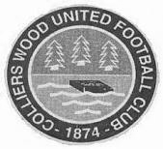
Colliers Wood United FC was founded way back in 1874 and the early years of their existence were spent in the Wimbledon and Sutton leagues before moving on to the Surrey Intermediate League (Southern Division). During the late sixties and early seventies, the club were members of the Surrey Senior League for a short time, playing in the newly formed division one where they won the league title in 1969/70. Over the years, “The Wood” has reached a number of Surrey FA Cup Finals. In 1988/89 they lost 1-2 to Bradbank Sports in the Intermediate Cup Final and in 1991/92 they beat Woking & Horsell 4-0 in the final of the same competition.

The local recreation ground prevented the progress of the club due to the limited facilities and a search for a new ground was launched. Adequate facilities were found at Wibbandune Sports Ground in 1991 and the ground has steadily improved since then.

2001/02 saw the club enter the Surrey County Senior League where they finished a creditable 5th. The following season, they finished as runners up. In 2002/03, the league amalgamated with the Combined Counties League and the club were founder members of the new Division 1 where they finished as runners up and were promoted to the Premier Division.

They have continued to improve. In 2004/05, they finished 14th of the 24 clubs. The following season, they finished fourth and had a fine FA Vase run, beating Chichester City United, Raynes Park Vale and Greenwich Borough, before losing to VCD Athletic in the 2nd Round.

In 2006/07 they entered the FA Cup for the first time, defeating Chipstead after a replay before succumbing to Worthing 0-3.

After a brief ground share at Croydon FC, the club moved back to Wibbandune where ground improvements included the addition of excellent floodlighting, a new covered terrace and a 120 seat stand.

In March 2012, the club added a new away team changing room, new spectator ground lavatories and re-laid the entire playing surface including drainage thanks to a £71,000 grant from the Football Association. They also reached the 2011/12 final of the League Cup at Farnborough FC on 4th May v Guernsey FC in front of 667 spectators, which they lost 0-2 after extra time, becoming the first club to keep a 90 minute clean sheet against The Islanders. Following a second renovation of the pitch in April, the club returned to Wibbandune in July 2013 and the under 18 youth section was re-started.

In 2014/15, Wood have reached the FA Vase 4th round (last 32 nationally) and the Surrey Senior Cup quarter finals for the first time in their history. They reached the final of the League Cup again in 2014/15, but once more lost in extra time, this time 1-2 to Camberley Town in front of 385 spectators at Woking FC. On Tuesday March 8th 2016, the club were awarded the FA Charter Standard status by the Football Association. This has now been extended to March 2018.

The club won the CCL Sportsmanship Award for 2015/16 having received just 32 cautions throughout the season.

Match and Ball Sponsorships – 2016/17
Opponent | Date | Match Sponsor | Ball Sponsor
Gravesham Borough | 07/08/16 | Club President - Stella Lamont
Gravesham Borough | 07/08/16 | Relocation Committee Member - Mike Lovett
CB Hounslow United | 16/08/16 | EEFC Management Committee
Abbey Rangers | 23/08/16 | Steve & Geoff Dyke
Horley Town (11.30am) | 29/08/16 | In Memory of Chris Henry
Abbey Rangers (LC) | 06/09/16 | Paul Merritt
Camberley Town | 10/09/16 | Building Shop Ltd
Knaphill | 24/09/16 | EEFC Holding Company Director – Pete Lumm
Bridon Ropes (FAV) | 22/10/16 | George and Joseph Saunders
Sutton Common Rovers | 08/11/15 | Alex McKay Senior
Abbey Rangers (FAV) | 13/11/16 | EEFC Holding Company Director – Dave Ellins
Windsor | 15/11/16 | In Memory of Wally Dyke
Bedfont Sports | 19/11/16 | John Bonner
AFC Hayes | 26/11/16 | Jack Jarman
Chipstead (SSC / DWT) | 06/12/16 | Trevor Stotten
Hanworth Villa | 13/12/16 | Roger and Carol Farrell
Chertsey Town | 17/12/16 | Kansei Engineering
Raynes Park Vale (11.30am) | 27/12/16 | In memory of Dave and Liz Marshall
Spelthorne Sports | 07/01/17 | Building Shop Ltd
Guildford City (SSC) | 10/01/17 | Super Six Winner – Rita Christian
Guildford City | 17/01/17 | Kansei Engineering
Badshot Lea | 04/02/17 | Kansei Engineering
Westfield | 18/02/17 | Tony Coome
Walton & Hersham | 04/03/17 | Super Six Winner – Rita Christian
Bedfont & Feltham | 07/03/17 | Programme Editor - Richard Lambert
Hartley Wintney | 18/03/17 | Kansei Engineering
Windsor (LC SF) | 21/03/17 | In memory of Bob Bexley
Farnham Town | 25/03/17 | In memory of Jean Bexley
Colliers Wood United (1pm) | 14/04/17 | Steve and Geoff Dyke
North Greenford United | 22/04/17 | Club President - Stella Lamont
For League, League Cup and Surrey Senior Cup Matches:
Match sponsorship - £40.00 Match ball sponsorship - £25.00. Combined £55.00.
For F.A. Cup and F.A. Vase matches:
Match sponsorship - £50.00 Match ball sponsorship - £30.00. Combined £65.00.

Sponsorship includes: (x2 for match, x3 for match and ball)

Admission, programmes, hospitality and advertising and mascot for the day (if required).
If you are interested, just speak to a Committee Member, or drop me an email at: richard.c.lambert@gmail.com

We also thank our Sponsors INTERCEM and G4 Group

Player Sponsorship
Here is the latest list, with new photos where available for the 2016/17 season showing all of our players and Management that are available for sponsorship.

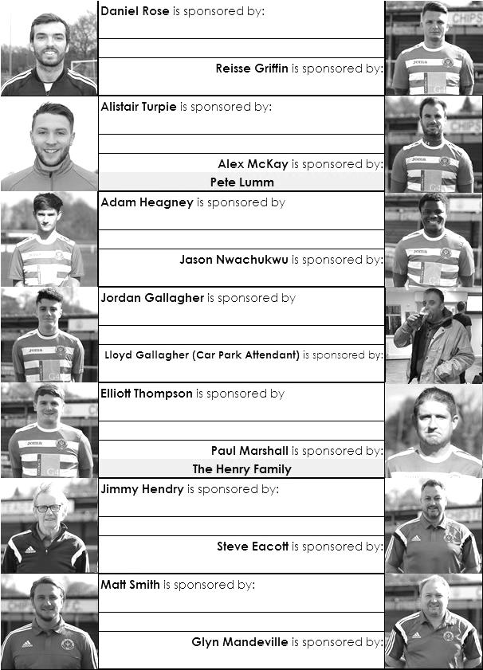

Sponsorship costs just £40 and it is easy to do. Just select a player who has not been previously sponsored and let a Committee Member know that you would like to sponsor them. Beware though. Until we have received the money it is possible for someone to jump in front of you, so don’t delay, sponsor today!
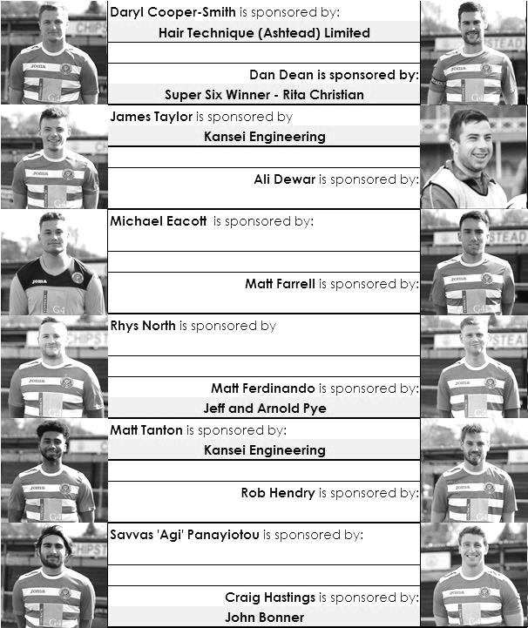

From behind the goal
Knaphill 1-2 Epsom & Ewell
Combined Counties League - Premier Division - Saturday 8th April 2017

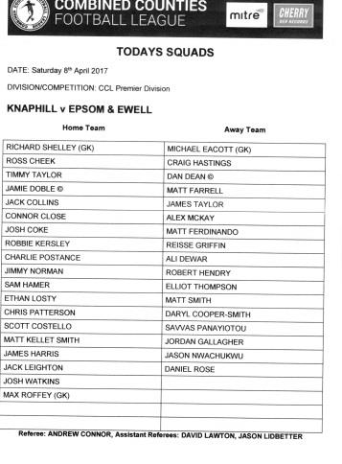
Heagney thunderbolt caps Salts fightback

On a day better suited to cricket, the Knappers and the Salts battled out a competitive but hugely uneventful match. In fact, the only reason it will be remembered years from now was for the winning goal; a fantastic strike from over 30 yards by Adam Heagney that flew in off the far post from out on the right flank. It was a goal worthy of winning any match, and in all honesty it was pretty much all the spectators got for their money.

With Captain Dan Dean suspended for accumulating ten bookings a couple of weeks ago, Matt Tanton and Matt Ferdinando were always unlikely to play much of a part in this match as a yellow card for either would have meant they would also reach ten but would also miss the League Cup Final in May. Tanton was absent anyway, as was James Taylor who was on a school trip. As a result Reisse Griffin continued at left back while Craig Hastings stepped in at the back pairing up with Alex McKay. Our midfield remained the same, (even if they always seem to wear different numbers when Glyn is away!), while Rob Hendry came in alongside Daryl Cooper-Smith in place of Jason Nwachukwu who started on the bench. Hendry received a proper battering from his marker today but stuck at his task gamely and with Cooper-Smith also up front, this was the closest I have seen us to a regular 4-4-2 formation in quite some time. Finally, Michael Eacott returned after spending the match at Camberley on the bench.

Last time we visited Redding Way the pitch was so soft that the referee spoke to both Managers about whether play should even commence. This time it was a lot firmer and as a result the ball just never seemed to be under control. With two teams of competitive players battling for it, a lot of scrappy play from either side was on show, although the home side nearly led early in the match with a snapshot that just cleared Eacott's crossbar. It was always going to be a tough day against the twin strike force of Charlie Postance and Jimmy Norman, both riding high in the goal scoring charts, but fortunately the home side decided to go for an aerial onslaught which McKay and Hastings were probably quite happy about. A tricky winger might have given us more trouble, but they didn't have one of those on show.

Our own tricky winger Jordan Gallagher was making his 50th appearance in this match, the first to do this in their debut season since Sam Currie in 2012/13, and in the 16th minute he threaded a clever ball through to Cooper-Smith whose shot was tipped wide of the far post by the always excellent Richard Shelley in the Knaphill goal. As it turned out, our man was offside but neither of the players knew that at the time. Next up it was Eacott's turn to shine as a Norman strike was tipped just over the bar at full stretch after it had seemed that he wouldn't get his shot away at all at one point. Big Mike had a bit of trouble with the subsequent corner though, dropping the routine catch and in the ensuing scramble the ball was headed just over the bar with Eacott nursing a sore hand for his trouble.

The rest of the first half passed by in a competitive blur with neither team really able to get the better of the other, although Cooper-Smith was able to get on the end of a long ball and hold his man off but in the act of shooting he was nudged again and scuffed his shot. It was a borderline call. Had the penalty been given it would have meant a red card for the offending defender who was making little or no attempt to get the ball, but I think on balance that the referee got it right as there wasn't quite enough there to give it. Had our man gone down in the box, it might well have resulted in a different call as we have all seen them given before.

The second half was barely twenty seconds old when Hendry got through on the right but his touch was heavy and Shelley was able to smother the ball before we were able to get a shot away. A minute later Cooper-Smith tried his luck from 25 yards but his low effort was always going just wide of the far post. The opposition were no better at finding the target though and just before the hour Norman sent a free kick from the edge of the area both high and wide.

I was beginning to think about which clichés to add into a report about an end of season goalless draw when the home side surprised everyone by taking the lead in the 62nd minute. Postance appeared to miscontrol a ball down the left, but as he missed it, McKay was also wrong footed and the striker was able to reach the loose ball first, cut in from the left and fire low past Eacott.

In a contest with few chances, there was every possibility that we might just have seen the defining moment of the match, but football as we all know is a funny old game, and despite the instructions from the Knaphill bench to retain their shape for the next few minutes, it was time to use another cliché about never being more vulnerable than after scoring a goal as we were level within a minute as Rhys North delivered a ball from the right and Matt Farrell got there first to steer the ball low beyond Shelley into the far corner of the net.

Immediately the game became interesting. Another deep crossfield ball from the right found Gallagher at the far post on the edge of the area and he cut inside before setting up Hendry who fired inches over the bar from 20 yards. Then in the 70th minute Gallagher set Cooper-Smith off down the left where he produced a great cross to the far post but the incoming North saw the ball a bit late and he was unable to keep his header down from ten yards. It would have been a great goal, but fortunately just two minutes later we were witnessing a goal of the season candidate from a most unlikely source.

In the 72nd minute a Cooper-Smith pass was intended for Heagney, but it was reached first by defender Josh Coke. However, his touch was a poor one and Heagney retrieved it from him before lashing the ball at goal from nearly 35 yards out and watching as it flew into the net off the far post. No keeper in the world could have saved it and somehow after staring disaster in the face just ten minutes earlier we were ahead. But we still had twenty minutes of this match to negotiate and if anything the home team became even more direct. Fortunately our experience at Camberley one week before had prepared us for this, although we were cut apart on one occasion when we were saved from a Norman equaliser by an Assistant's offside flag.

We were able to survive mostly untroubled though and held on to claim all three points, completing a league double, following our 4-0 win at High Road back in September and ensuring that we remained unbeaten from our four visits to Redding Way. However, none of that would be possible to report on without Heagney's heroics. He won't be forgetting his first goal for the club for many years and nor will anyone who saw it!

Epsom and Ewell: Michael Eacott, Adam Heagney, Reisse Griffin, Craig Hastings, Alex McKay, Savvas 'Agi' Panayiotou, Rhys North, Matt Farrell (c), Daryl Cooper-Smith, Rob Hendry, Jordan Gallagher
Sub: Jason Nwachukwu for North (74), Matt Ferdinando for Gallagher (92)

Surrey Senior Cup
Third Round
Whyteleafe | 2-0 | Egham Town
Badshot Lea | 0-2 | Raynes Park Vale
Epsom & Ewell | 1-2 | Guildford City
Dorking Wanderers | 1-1 8p7 | Sutton Common Rovers
Chertsey Town | 1-0 | Kingstonian
Woking | 2-0 | Leatherhead
Merstham | 5-1 | Walton & Hersham
Tooting & Mitcham United | 0-1 | Knaphill
Quarter Final
Guildford City | 2-1 | Raynes Park Vale
Chertsey Town | 0-3 | Dorking Wanderers
Merstham | 2-1 | Whyteleafe
Woking | 3-1 | Knaphill
Semi Final
Guildford City | 1-2 | Woking
Dorking Wanderers | 2-3 | Merstham

F.A. Vase
Fifth Round – 28th / 29th January
Cleethorpes Town | 3-2 | Atherton Collieries
Southall | 4-2 | Exmouth Town
Bromsgrove Sporting | 2-1 | Bristol Manor Farm
Crowborough Athletic | 3-6 | Coleshill Town
Hinckley AFC | 3-4+ | Buckland Athletic
Newport Pagnell Town | 3-2+ | Sunderland RCA
Ely City | 0-3 | Sporting Khalsa
Team Solent | 2-5 | South Shields
Quarter - Final – 18th February
South Shields | 6-1 | Newport Pagnell Town
Southall | 2-5 | Cleethorpes Town
Bromsgrove Sporting | 2-0 | Buckland Athletic
Coleshill Town | 2-0 | Sporting Khalsa
Semi - Finals - two legs – 11th & 18th March
Coleshill Town | 1-2 | South Shields
South Shields | 4-0 | Coleshill Town
Bromsgrove Sporting | 1-1 | Cleethorpes Town
Cleethorpes Town | 1-0 | Bromsgrove Sporting

CCL Premier Division Club Directory
ABBEY RANGERS Telephone: 01932-422962 - Ground: Addlestone Moor, Addlestone, Surrey KT15 2QH - Colours: Black & White Stripes/Black/Black

A.F.C. HAYES Telephone: 0208-845-0110 - Ground: Farm Park, Kingshill Avenue, Hayes, Middx. UB4 8DD - Colours: Blue and White Stripes/Blue/Blue

BADSHOT LEA Telephone: 01252-320385 - Ground: Ash United FC, Shawfield Stadium, Youngs Drive, Shawfields Road, Ash, Hampshire. GU12 6RE - Colours: Claret/White/Claret

BEDFONT & FELTHAM Telephone: 0208 890 7264 - Ground: The Orchard, Hatton Road, Bedfont, Middx TW14 9QT - Colours: Yellow & Blue/Blue/Blue

BEDFONT SPORTS Telephone: 0208-831-9067 - Ground: Bedfont Sports Club, Hatton Road, Bedfont, Middx TW14 8JA - Colours: Red & Black Hoops/Black/Red & Black Hoops

CAMBERLEY TOWN Telephone: 01276-65392 - Ground: Krooner Park, Wilton Road, Camberley, Surrey. GU15 2QW - Colours: Red & White Stripes/Blue/Red

CB HOUNSLOW UNITED Telephone: 0208 890 7264 - Ground: The Orchard, Hatton Road, Bedfont, Middx TW14 9QT - Colours: Green/Black/Green

CHERTSEY TOWN Telephone: 01932-561774 - Ground: Alwyns Lane, Chertsey, Surrey. KT16 9DW - Colours: Royal Blue & White Stripes/Royal Blue/Royal Blue

COLLIERS WOOD UNITED Telephone: 0208-942 8062 - Ground: Wibbandune Sports Ground, Robin Hood Way, Wimbledon. SW20 0AA - Colours: Blue & Black Stripes/Black/Black
EPSOM & EWELL Telephone: 01737-553250 - Ground: Chipstead FC, High Road, Chipstead, Surrey. CR5 3SF - Colours: Royal Blue & White Hoops/Royal Blue/Royal Blue

FARNHAM TOWN Telephone: 01252-715305 Ground: Memorial Ground, Babbs Mead, West Street, Farnham, Surrey. GU9 7DY Colours: - Claret & Sky Blue /White/ Claret & Sky Blue

GUILDFORD CITY Telephone: 01483-443322 - Ground: The Spectrum, Parkway, Guildford, Surrey. GU1 1UP - Colours: Red & White Stripes/Black/Black

HANWORTH VILLA Telephone: 0208-831-9391 - Ground: Rectory Meadows, Park Road, off Hounslow Road, Hanworth, Middlesex. TW13 6PN - Colours: Red & White Stripes/Black/Black

HARTLEY WINTNEY Telephone: 01252-843586 - Ground: Memorial Playing Fields, Green Lane, Hartley Wintney, Hants RG27 8DL - Colours: Orange & Black/ Orange /Orange

HORLEY TOWN Telephone: 01293-822000 - Ground: The New Defence, Anderson Way, Court Lodge Road, Horley, Surrey. RH6 8SP - Colours: Claret & Sky Blue/Claret/Claret

KNAPHILL Telephone: 01483-475150 - Ground: Brookwood Country Park, Redding Way, Lower Guildford Road, Knaphill, Surrey. GU21 2AY - Colours: Red/Black/Red

NORTH GREENFORD UNITED Telephone: 0208 422 8923 - Ground: Berkeley Fields, Berkeley Avenue, Greenford, Middx UB6 0NX - Colours: Royal Blue & White/Royal Blue/Royal Blue

SUTTON COMMON ROVERS Telephone: 01932-866386 - Ground: Sutton United FC, Gander Green Lane, Sutton, Surrey SM1 2EY - Colours: Yellow/Black/Black

RAYNES PARK VALE Telephone: 020-8540-8843 - Ground: Prince Georges Playing Field, Grand Drive, Raynes Park, London. SW20 9NB - Colours: Blue/Blue/Red

SPELTHORNE SPORTS Telephone: 01932-961055 - Ground: Spelthorne Sports Club, Staines Road, Ashford Common, Ashford, Middx. TW15 1RY - Colours: Light & Dark Blue/Dark Blue/Light Blue

WALTON & HERSHAM Telephone: 01932 245263 - Ground: Stompond Lane, Walton on Thames, Surrey KT12 1HF - Colours: Red/Red/Red

WESTFIELD Telephone: 01483-771106 - Ground: Woking Park, Kingfield Road, Woking, Surrey. GU22 9BA - Colours: Yellow/Black/Black

WINDSOR Telephone: 01753-860656 - Ground: Stag Meadow, St Leonards Road, Windsor, Berks SL4 3DR - Colours: Red/Red/Red

Combined Counties League Premier Division
Opponents All-time Records
incl Saturday 8th  April | P | W | D | L | F | A | PPG | GD | Best  Win | Worst  Loss
Bedfont & Feltham | 2 | 2 | 0 | 0 | 13 | 3 | 3.00 | +10 | 9-2 | X
Spelthorne Sports* | 7 | 5 | 2 | 0 | 15 | 6 | 2.43 | +9 | 6-2 | X
Sutton Common Rovers | 12 | 9 | 2 | 1 | 30 | 14 | 2.42 | +16 | 4-0 | 1-4
Abbey Rangers | 4 | 3 | 0 | 1 | 11 | 4 | 2.25 | +7 | 7-1 | 2-3
Horley Town | 29 | 20 | 5 | 4 | 65 | 30 | 2.24 | +35 | 6-0 | 1-3
Bedfont Sports | 11 | 7 | 2 | 2 | 21 | 12 | 2.09 | +9 | 5-1 | 0-4
Colliers Wood United | 22 | 14 | 2 | 6 | 45 | 33 | 2.00 | +12 | 4-0 | 0-5
Knaphill | 8 | 5 | 1 | 2 | 17 | 9 | 2.00 | +7 | 4-0 | 1-2
Westfield | 20 | 12 | 3 | 5 | 42 | 32 | 1.95 | +10 | 6-1 | 0-4
Guildford City | 18 | 11 | 1 | 6 | 35 | 22 | 1.89 | +13 | 5-1 | 1-5
Farnham Town | 15 | 8 | 3 | 4 | 27 | 25 | 1.80 | +2 | 3-1 | 1-4
Badshot Lea | 19 | 9 | 3 | 7 | 39 | 36 | 1.74 | +3 | 4-1 | 0-4
Hanworth Villa | 17 | 8 | 4 | 5 | 38 | 27 | 1.65 | +11 | 5-0 | 1-4
Walton & Hersham | 52 | 25 | 11 | 16 | 105 | 99 | 1.65 | +6 | 8-0 | 1-9
Raynes Park Vale | 28 | 13 | 7 | 8 | 59 | 38 | 1.64 | +21 | 6-1 | 0-2
Camberley Town* | 90 | 38 | 22 | 29 | 158 | 125 | 1.51 | +33 | 9-1 | 0-4
Windsor | 50 | 20 | 12 | 18 | 92 | 90 | 1.44 | +2 | 4-0 | 0-6
Chertsey Town | 49 | 19 | 5 | 25 | 75 | 87 | 1.27 | -12 | 3-0 | 0-7
Hartley Wintney | 12 | 4 | 3 | 5 | 26 | 21 | 1.25 | +5 | 5-0 | 2-4
North Greenford United | 11 | 3 | 2 | 6 | 15 | 20 | 1.00 | -5 | 3-0 | 1-4
CB Hounslow United | 3 | 1 | 0 | 2 | 4 | 7 | 1.00 | -3 | 2-0 | 1-5
AFC Hayes | 10 | 2 | 3 | 5 | 18 | 18 | 0.90 | 0 | 7-0 | 0-3
* includes one abandoned match v Camberley and one loss on penalties v Spelthorne

Alternative Match Report
When we played Farnham, Nathan asked me if he could write a match report. As he is only just 9 I didn’t think he was quite ready for a 1,000 word report (some say the current editor can’t do it either!) so I thought of doing one in a different style that would appeal to the youngsters out there in a language only they understand! He rose to the challenge and I hope you enjoy the club’s first ever Emoji report!

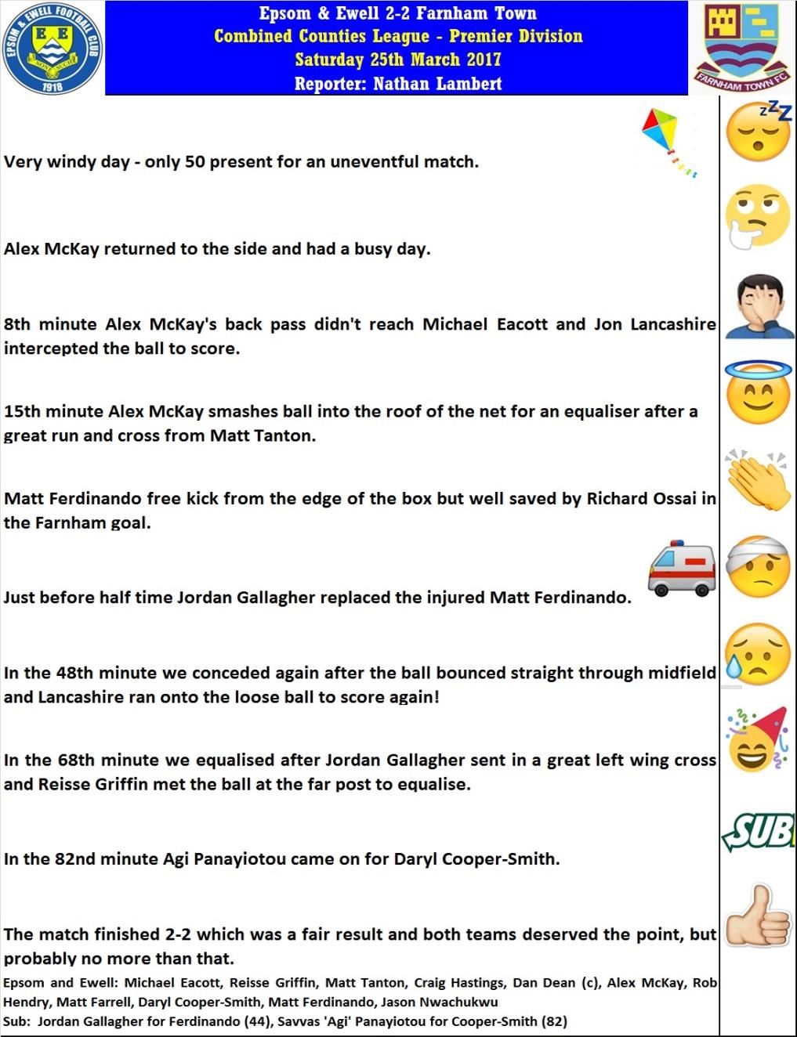

Combined Counties League – Premier Division
Friday, 14th April 2017 - Kick-off 1.00 p.m.

Epsom and Ewell  (Royal Blue & White hoops) | V |  | Colliers Wood United  (Red and White Stripes)
Squad | NUMBERS |  | Squad
Michael Eacott |  |  | Arjuna Adlam
Adam Heagney |  |  | Dean Ennor
Matt Tanton |  |  | Cedric Abraham
James Taylor |  |  | Dan Hughes
© Dan Dean |  |  | Jake Hill
Savvas ‘Agi’ Panayiotou |  |  | Jose Antonio
Jordan Gallagher |  |  | Luke Harmsworth
Matt Farrell |  |  | Will Boye
Rob Hendry |  |  | Anis Nuur
Matt Ferdinando |  |  | Darren Caesar
Reisse Griffin |  |  | Hussain Mohammed
Jason Nwachukwu |  |  | Moses Kaddu
Craig Hastings |  |  | Theo Woodhouse
Daryl Cooper-Smith |  |  | Tyrone Newton ©
Alex McKay |  |  | Emmanuel Shoderu
Rhys North |  |  | Ryan Doherty
Alistair Turpie |  |  | Eli Ogunseye
Matt Smith |  |  | Mario Embalo
Ali Dewar |  |  | Sanchez Benali
Glyn Mandeville | MANAGER |  | Tony Hurrell
Matt Smith | ASSISTANT |  | Paul Norris
Steve Eacott / Alex McKay/  Jimmy Hendry | COACHES / PHYSIO |  | Steve Turner
REFEREE: Z.Jacquart
ASSISTANTS: K.Corrick, R.Wells
Today’s match and Match Ball are kindly sponsored
By Steve and Geoff Dyke

OUR FINAL VISITORS TO HIGH ROAD

North Greenford United

Combined Counties League – Premier Division
Saturday 22nd April 2017 – 3.00 p.m.

